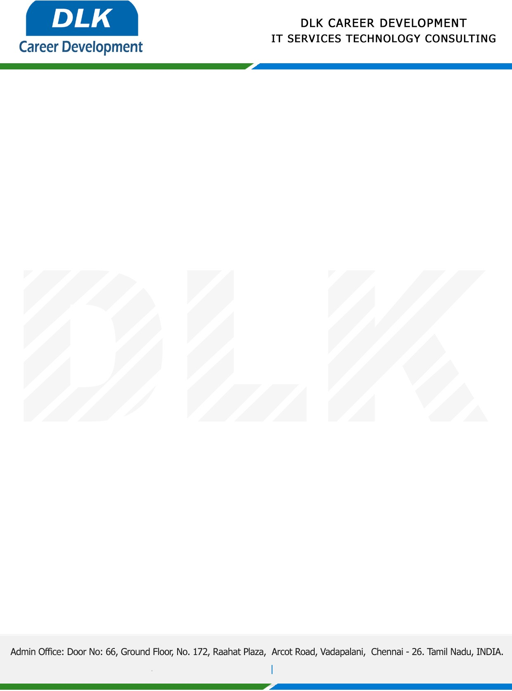

**Date: 19/ February /2023**

**SUB: PROJECT COMPLETION CERTIFICATE**

This is to certify that **MS** **Theresa R** **(REG NO:** **30220u09012) B.sc (Computer science)** Final year student of **Jaya Arakkonam Arts and Science College** has Successfully Completed the Project Work under the domain of **“Python”** in our organization during the Period **(20 January 2023** to **19 February 2023).**

We appreciate your interest in **DLK CAREER DEVELOPMENT**

**“Best Wishes for Your Future Endeavors “**

For **DLK CAREER DEVELOPMENT**

